DBMS

Team members:

* Yousef mohamed fathy.
* Mohamed mohamed abdelhakem.
* Karim atef ahmed.
* Abdallah mohamed fawzy elsman.

UML design:

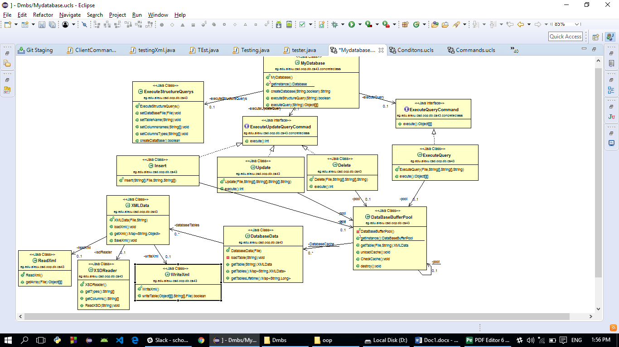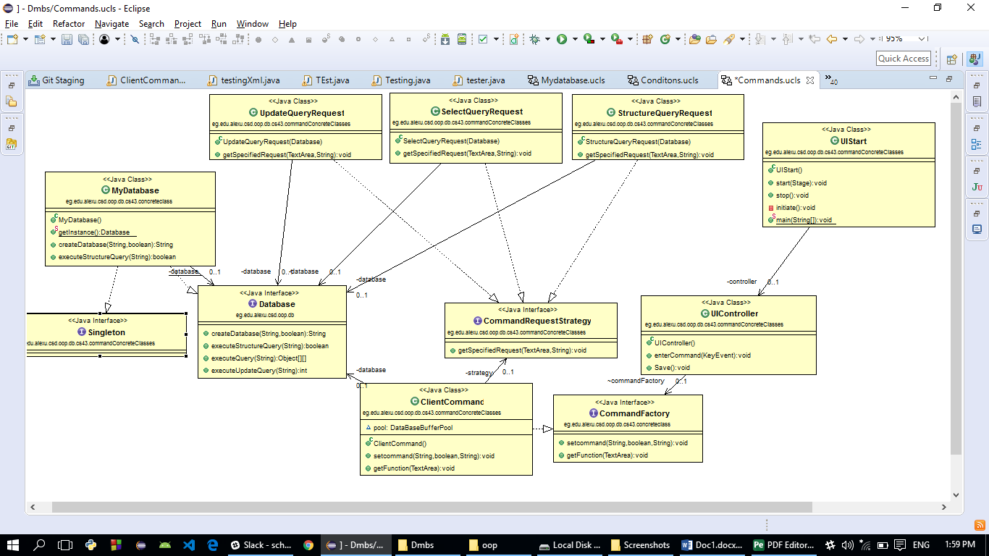

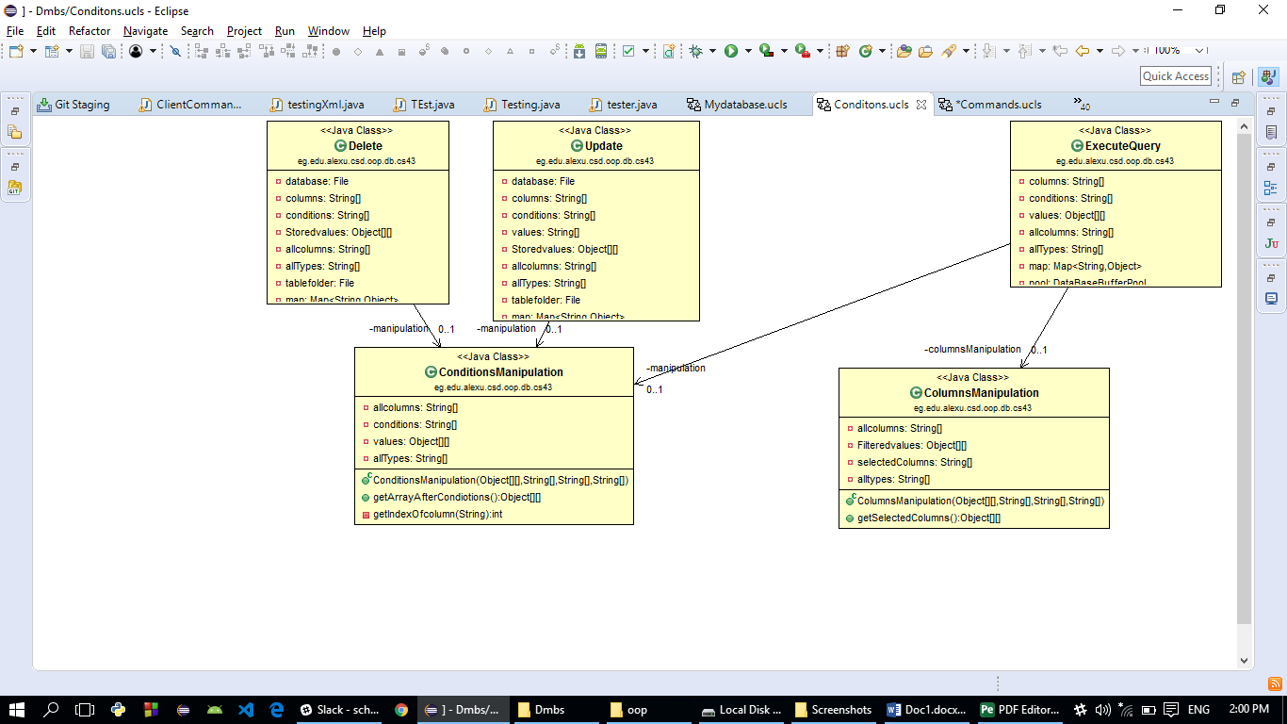

* UIStart class is the GUI starter and calls the UI Controller and when stopped it saves the data in the cache.
* UIController Calls the command factory interface to initialize the command Request strategy interface which is implemented by update query request , structure query request and select query request and the three classes calls the My database singleton class.
* My database class calls the execute Update query interface which is implemented by update, select and delete class, the execute query interface which is implemented by the execute query, the execute structure query.
* Insert, delete, update and select classes call the buffer pool.
* The buffer pool when called loads the requested table and pushes it to the cache when 40 seconds passes and no change is applied to a table in the cache, it pops these table from the cache and saves it to the file system.
* Conditions manipulation is class that manipulates the conditions.

User guide:

* Write the command in the text field in the GUI and press enter if the command syntax is right, it is not applied in case of wrong syntax.
* In case of selection the requested columns is passed to the text area.
* In case of update the number of updated columns is passed to the text area.
* In case of creating if the command succeeded, you are informed in the text area.

Sample runs:

